**DAILY ONLINE ACTIVITIES SUMMARY**

|  |  |  |  |  |  |  |  |  |
| --- | --- | --- | --- | --- | --- | --- | --- | --- |
| **Date:** | **10-6-2020** | | | | | **Name:** | **Pavana P** | |
| **Sem & Sec** | **6A** | | | | | **USN:** | **4AL17CS057** | |
| **Online Test Summary** | | | | | | | | |
| **Subject** | | **SSCD** | | | | | | |
| **Max. Marks** | | **30** | | **Score** | | | **29** | |
| **Certification Course Summary** | | | | | | | | |
| **Course** | **Build an IOT Blockchain Network for a supply chain.** | | | | | | | |
| **Certificate Provider** | | | Cognitive classes | | **Duration** | | | 4 hours |
| **Coding Challenges** | | | | | | | | |
| **Problem Statement:**  1.Write a C Program to print the sum of boundary elements of a matrix  2. Write a Java program to find the maximum and minimum value node from a circular linked list | | | | | | | | |
| **Status: Completed** | | | | | | | | |
| **Uploaded the report in Github** | | | | | **YES** | | | |
| **If yes Repository name** | | | | | **DAILY STATUS** | | | |
| **Uploaded the report in slack** | | | | | **YES** | | | |

.

**Online Test :**

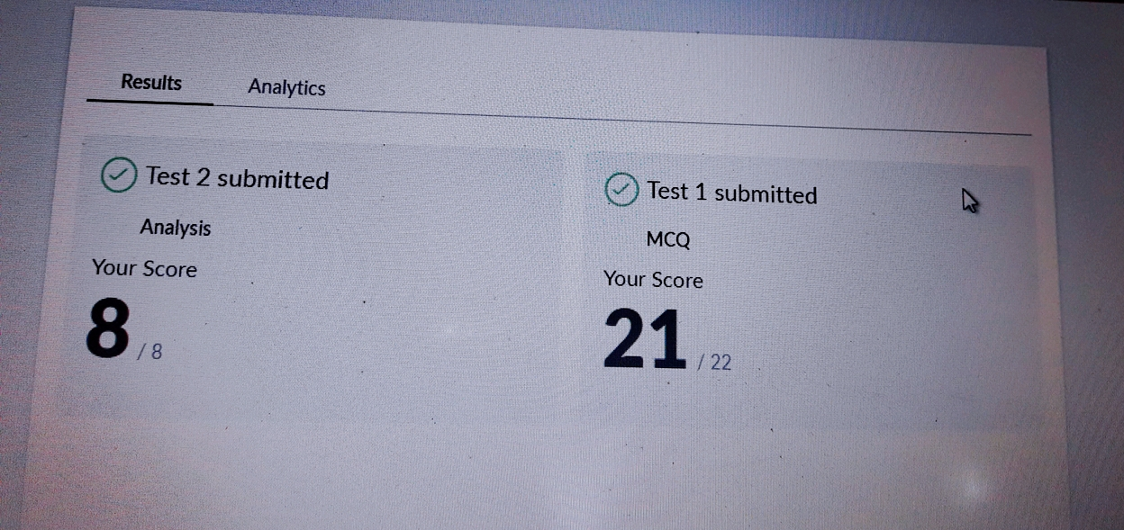Subject:-SSCD  
**Certification Course Details:**

**Build an IOT Blockchain Network for a supply chain:**

Today I have completed these topics:

1.Asset Tracker Simulator.

2.Import and Deploy the simulator flow.

3.Tracking the Asset in the Dashboard.

.

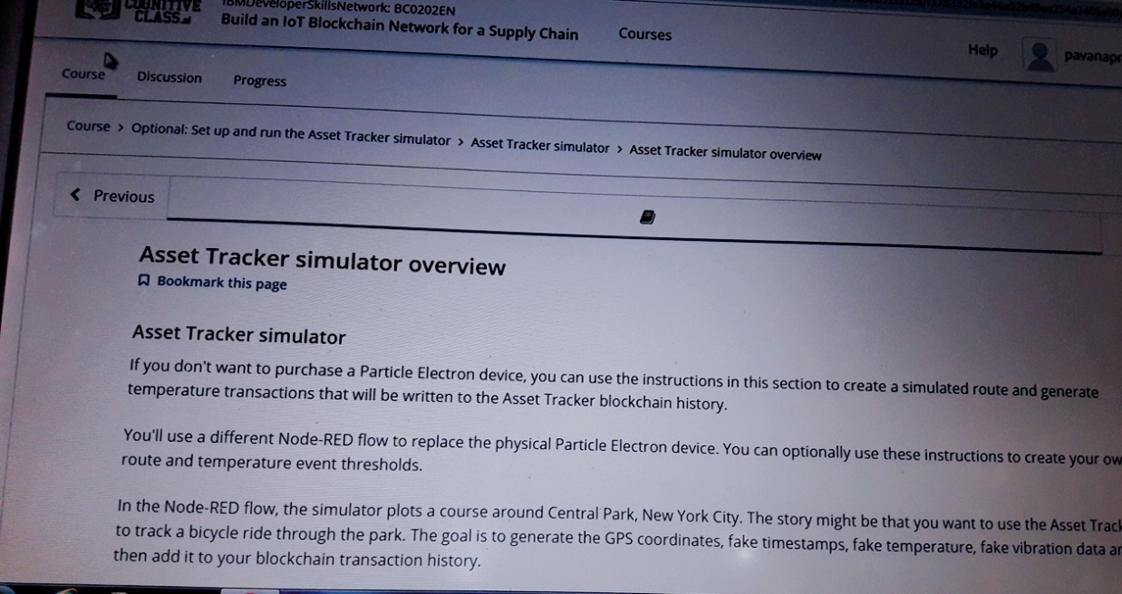

**Coding Challenges Details:**

**https://github.com/pavana-p-kulal/DAILY-STATUS/tree/master/10-6-20/Online%20Coding**